# 计算机程序设计基础

# 实验报告

## 专业班级：软工2303班

## 学号：8209230311

## 姓名：周子晨

### 实验一

1. 错误：使用了未定义的变量k。改正：int k=0; int i =k+1; cout<<i++<<endl;

2.求圆锥体积

#include<iostream>

using namespace std;

int main()

{

double R, h;

cout << "请输入圆锥底的半径R = " << endl;

cin >> R;

cout << "请输入圆椎的锥高h = " << endl;

cin>> h;

const double PI = 3.14;

double V = (PI * R * R * h) / 3;

cout << "圆锥的体积为：" << V<<endl;

return 0;

}

运行结果：



3. #include<iostream>

using namespace std;

int main()

{

cout << "char length:" << sizeof(char) << endl;

cout << "short length:" << sizeof(short) << endl;

cout << "int length:" << sizeof(int) << endl;

cout << "float length:" << sizeof(float) << endl;

cout << "long length:" << sizeof(long) << endl;

cout << "unsigned length:" << sizeof(unsigned) << endl;

cout << "long long length:" << sizeof(long long) << endl;

cout << "double length:" << sizeof(double) << endl;

return 0;

}

执行结果：

4.代码改正后：

#include<iostream>

#include<iomanip>

using namespace std;

int main()

{

unsigned int testUnint = 65534;//oxfffe

cout << "output in unsigned int 1 type:" << testUnint<< endl;//<<oct;

cout << "output in char type:!" << static_cast <char>(testUnint) << endl;

cout << "output in short type:" << static_cast <short>(testUnint) << endl;//为什么结果为-2?:

cout << "output in int type:" << static_cast<int> (testUnint) << endl;

cout << "output in double type:" << static_cast<double>(testUnint) << endl;

cout << "output in double type:" << setprecision(4) << static_cast<double>(testUnint) << endl;

cout << "output in Hex unsigned int type:" << hex << testUnint << endl; //16进制输出

cout << "Output in Oct unsigned int type: " << oct << testUnint << endl;//8进制输出

float num = 1.56;

cout << "num type in int = " << (int)num << endl;

system("pause");

return 0;

}

运行结果：

5.华氏温度与摄氏温度转换输出：

#include<iostream>

#include<iomanip>

using namespace std;

int main()

{

cout << "请输入华氏温度：" << endl;

double F,C;

cin >> F;

C = (F - 32) * 5 / 9;

cout << "摄氏温度为：" <<setprecision(3)<< C << endl;

return 0;

}

运行结果：

### 遇到的问题与解决办法：

问题：实验1.5 保留两位小数算法

解决：setprecision(3) 设置精度为3

# 实验二,数据结构

1. #include<iostream>

using namespace std;

int main()

{

cout << "请输入一个字符：" << endl;

char m;

cin >> m;

if (m >= 'a' && m <= 'z')

{

char l2;

l2 = m - 32;

cout << l2 << endl;

}

else if(m >= 'A' && m <= 'Z')

{

cout << m + 1 << endl;

}

return 0;

}

运行结果：

输入小写字母时：



输入大写字母时：



2.

#include<iostream>

using namespace std;

int main()

{

double x, y;

int k = 3;

while (1)

{

cout << "请输入x:" << endl;

cin >> x;

if (x > 0 && x < 1)

{

y = 3 - 2 * x;

cout << "y = " << y << endl;

}

else if (x >= 1 && x < 5)

{

y = 2 / (4 * x) + 1;

cout << "y = " << y << endl;

}

else if (x >= 5 && x < 10)

{

y = x * x;

cout << "y = " << y << endl;

}

k--;

if (k == 0)

{

break;

}

}

return 0;

}

运行结果：

3.

#include<iostream>

using namespace std;

int main()

{

double a, b, c;

cout << "请输入三角形的三边长：" << endl;

cin >> a >> b >> c;

if (a + b > c && a + c > b && b + c > a) //判断是否为三角形

{

if (a == b || a == c || b == c || a == b == c)

{

cout << "该三角形是等腰三角形。" << endl;

}

else

{

cout << "该三角形不是等腰三角形。" << endl;

}

}

else

{

cout << "这三边无法组成三角形。" << endl;

}

return 0;

}

运行结果：

4.

#include<iostream>

using namespace std;

int main()

{

cout << "请输入算式：" << endl;

int a, b, sum;

char fl;

cin >> a >> fl >> b;

switch (fl)

{

case'+':

sum = a + b;

break;

case'-':

sum = a - b;

break;

case'*':

sum = a * b;

break;

case'/':

if (b == 0)

{

cout << "算式错误" << endl;

}

sum = a / b;

break;

case'%':

sum = a % b;

cout << "sum = " << sum << endl;

break;

default:

cout << "算式错误" << endl;

}

cout << "sum = "<<sum << endl;

return 0;

}

运行结果：



5.

#include<iostream>

using namespace std;

int main()

{

char c;

cout << "请输入一串字符：" << endl;

int english = 0, num = 0, space = 0, other = 0;

while ((c = getchar()) != '\n')

{

if (c >= 'a' && c <= 'z' || c >= 'A' && c <= 'Z')

{

english++;

}

else if (c == ' ')

{

space++;

}

else if (c >= '0' && c <= '9')

{

num++;

}

else other++;

}

cout << "english = " << english

<< "\nnum = " << num

<< "\nspace = " << space

<< "\nother = " << other << endl;

return 0;

}

运行结果：



6.

#include<iostream>

using namespace std;

int main()

{

int a, b, Y, B;

cout << "请输入两个数：" << endl;

cin >> a >> b;

for (int i = 1; i <= a && i <= b; i++)

{

if (a % i == 0 && b % i == 0)

{

Y = i;

}

}

cout << "最大公因数为：" << Y << endl;

for (int I = 1;; I++)

{

if (I % a == 0 && I % b == 0)

{

B = I;

break;

}

}

cout << "最小公倍数为：" <<B<< endl;

return 0;

}

运行结果：



7.

#include<iostream>

using namespace std;

int main()

{

for (int i = 1; i <= 5; i++)

{

for (int j = 1; j <= i; j++)

{

cout << "*";

}

cout << endl;

}

return 0;

}

运行结果：



8.

#include<iostream>

#include<cmath>

using namespace std;

int main()

{

cout << "请输入a的值：" << endl;

double a,x,x1;

cin >> a;

x = a;

if (a < 0)

{

cout << "error" << endl;

}

if (a == 0)

{

cout << "0的平方根为0." << endl;

}

if (a > 0)

{

while (1)

{

x1 = (x + a / x) / 2;

if (fabs(x - x1 < 1e-5))

{

cout << "x = " << x << endl;

break;

}

x = x1;

}

}

return 0;

}

运行结果：



思考一：输入的a值为负：

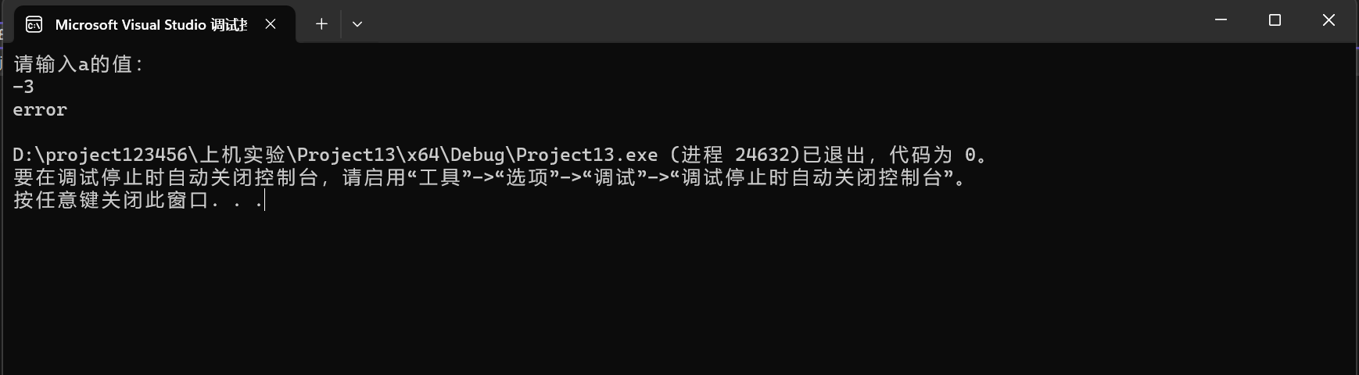

思考二：不能。 更小之后并没有继续迭代。

9.

#include<iostream>

using namespace std;

int main()

{

int sum = 0, j = 0;

for (int i = 2; i <= 100; i *= 2)

{

sum = i + sum;

j++;

}

cout << "平均每天花" << 0.8 * sum / j << "元" << endl;

return 0;

}

运行结果：



### 遇到的问题与解决办法：

问题1：实验2.1 不知道怎么输出ASCII码

解决：查找资料得知字符+1即可

问题2：实验2.5 不知道如何获取字符个数

解决：上网查询得知getchar（）用法

有了getchar便不再需要cin，getchar即有输入。

问题3：实验2.8 不知道绝对值如何表示

解决：上网查询fbs